Motives for Imperialism
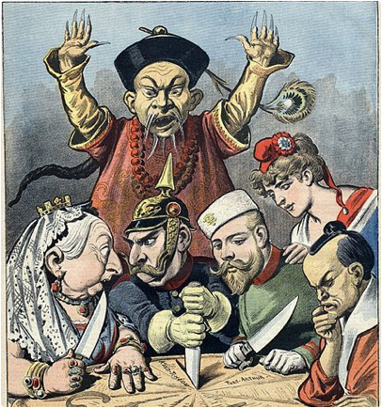

Five Motives for Imperialism
Various motives prompt empires to seek to expand their rule over other countries or territories. These include economic, exploratory, ethnocentric (having or based on the idea that your own group or culture is better or more important than others), political, and religious motives.
- Economic: Imperial governments, and/or private companies under those governments, sought ways to maximise profits. Economic expansion demanded cheap labour, access to or control of markets to sell or buy products, and natural resources such as precious metals and land; governments have met these demands by hook (tribute) or by crook (plunder). After the advent of the Industrial Revolution, dependent colonies often provided to European factories and markets the raw materials they needed to manufacture products. Imperial merchants often established trading posts and warehouses, created transportation infrastructure, and sought control over strategic choke points, such as the Suez Canal in Egypt (which allows boats to cut thousands of miles of travel time between Asia and Europe). Imperial powers often competed with each over for the best potential resources, markets, and trade.

- Exploratory: Imperial nations or their citizens wanted to explore territory that was, to them, unknown. Sometimes they did this for the purpose of medical or scientific research. At other times, they did it for the sense of adventure. Invariably, imperial explorers sought to discover, map, and claim territory before their imperial competition did, partly for national and personal glory and partly to serve the imperialist goal of expansion.

- Ethnocentric/Ideological: Imperial nations sometimes believed that their cultural values or beliefs were superior to other nations or groups. Imperial conquest, they believed, would bring successful culture to inferior people. In the late 19th century, for example, European powers clung to the racist belief that inferior races should be conquered in order to “civilise” them. The Europeans acted on their ethnocentrism, the belief that one race or nation is superior to others.

- Political: Patriotism and growing imperial power spurred countries to compete with others for supremacy. It’s a matter of national pride, prestige and security. Empires sought strategic territory to ensure access for their navies and armies around the world. The empire must be defended and, better yet, expanded. Political motives were often triggered as responses to perceived threats to the security or prestige of the imperial power or its citizens abroad.

- Religious: During imperial expansion, religious people sometimes set out to convert new members of their religion and, thus, their empire. Christian missionaries from Europe, for example, established churches in conquered territories during the nineteenth century. In doing so, they also spread Western cultural values. Typically, missionaries spread the imperial nation’s language through educational and religious interactions, although some missionaries helped to preserve indigenous languages. British missionaries led the charge to stop the slave trade in the nineteenth century, while others, such as French missionaries in Vietnam during the same time period, clamoured for their country to take over a nation.

Primary Source Images
Directions: Examine this gallery of eight primary source images of maps, advertisements, sketches, and photographs. Annotate each source and decide which imperial motives are represented in each image? – remember there is often more than one motive for European imperialism. Which motive is represented most often in these images? Why might that motive be represented more often?

Source 1 - British Lipton Tea advertisement in the 1890s

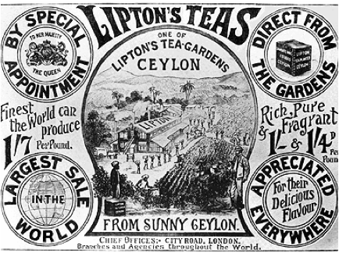

Imperial motives seen in the image:
Economic: goods from Ceylon transported to London, use of indigenous labour and resources, exportation of industrial technology
Political: gaining national prestige through international trade

Source 2 - Open-shaft diamond mining at Kimberley, South Africa, in 1872
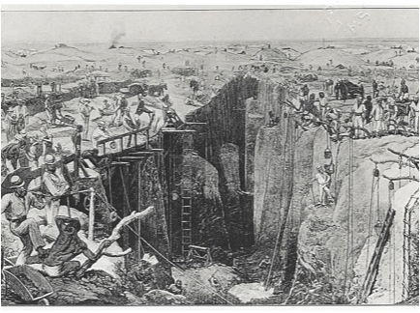

Source 3 - Suez Canal, between Kantara and El-Fedane. The first vessels through the Canal. 19th century image. Scanned from engraving in "Appleton's Journal of Popular Literature, Science, and Art", 1869.

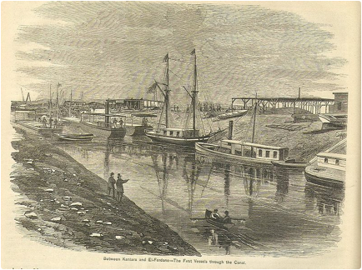

Source 4 - An advertisement for Pears’ Soap from the 1890s
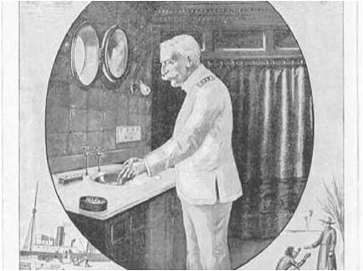

Source 5
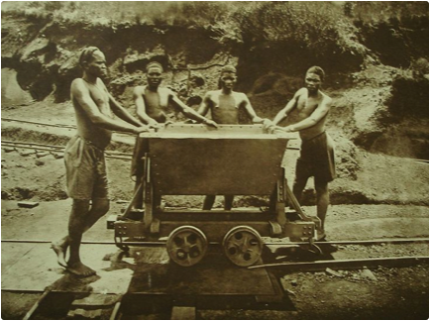
Source 6 - Ship at the Culebra Cut while transiting the Panama Canal, in 1915, photograph.
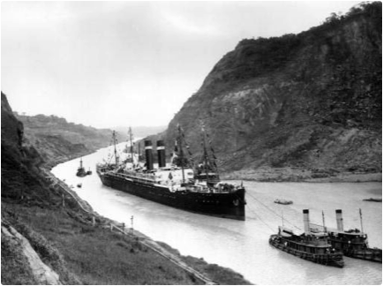
Source 7 - King Prempeh, ruler of the large West African Asante (Ashanti) state, (now Ghana) formally submits to British officers in 1896. The Queen Mother (on the right) also makes submission.
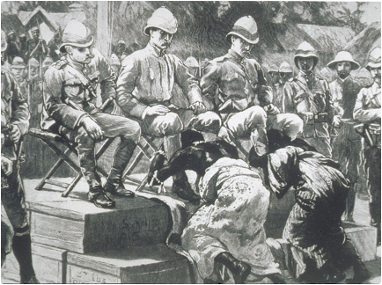
Source 8 - An 18th-century portrait depicting Fort St. George, the first major British settlement in India and the foundation stone of Chennai (formerly Madras).
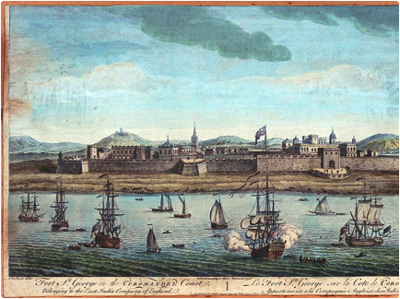

Which motive is represented most often in these images?

Why might that motive be represented more often?

